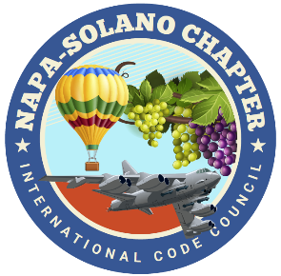

2024
BOARD OF DIRECTORS:

PRESIDENT
Rick Ishibashi
Solano County
Building Inspector

Vice-President
Nandi Cola-Loggins
Solano Economic/Bayren

SECRETARY
Brian Frenger
CBO City of Elk Grove
CSG Consultants

TREASURER
Erik Hagström
County of Solano
Planning - Civic Spark Fellow

PAST PRESIDENT
Bill Collins
County of Lake
Building Official

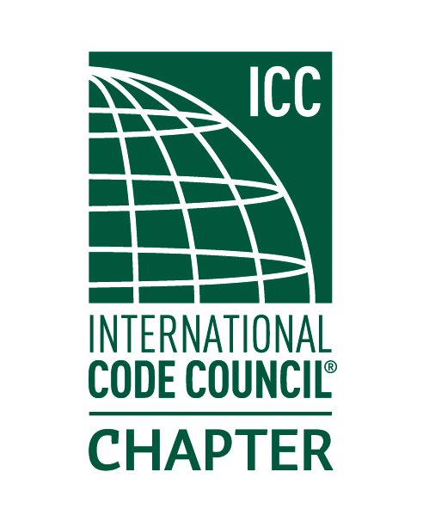

NAPA SOLANO ICC CHAPTER MEETING

May 1st, 2024
New location: Fairfield Codelia Library, 5050 Business Center Dr. Fairfield 94534-Second floor Suite 200

- CALL TO ORDER:

- SELF INTRODUCTIONS:

- PLEDGE OF ALLEGIANCE:

- APPROVAL OF APRIL MINUTES:

- TREASURER REPORT: Erik Hagström

- DINNER: Provided by Kinders BBQ

- CODE QUIZ: Provided by: BPR Consulting.

- SPEAKER: Josh Pino- Quality Control Manager with Kustom Disaster Recovery. The following topics will be discussed.
- Insurance claim process
- Site mitigation
- Reconstruction of damaged properties
- Interaction with local building & fire departments
- Current jurisdictional permitting

- AGENCIES REPORT
- CALBO-California Building Officials
- ICC Region 1
- California Energy Commission
- CBOAC- County Building Officials of California
- NEW BUSINESS
- Nandi-ICC Chapter Leadership Academy Orlando Florida April 5th-7th
- Reminder: Chapter Lunch meeting July 11:00-1:00 Fairfield Cordelia Library.
- May-Building Safety Month Proclamation

- OLD BUSINESS
- Website update
- Solar App Training April 17th -Special thanks to Mike Schiele City of Benicia!
- Education Committee Volunteers still needed!

- INSPECTOR TIME: Please bring your code items for discussion!

- ADJOURNMENT

