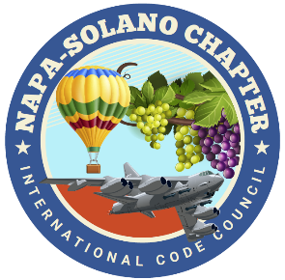

2024
BOARD OF DIRECTORS:

PRESIDENT
Rick Ishibashi
Solano County
Building Inspector

Vice-President
Nandi Cola-Loggins
Solano Economic/Bayren

SECRETARY
Brian Frenger
CBO City of Elk Grove
CSG Consultants

TREASURER
Erik Hagström
County of Solano
Planning - Civic Spark Fellow

PAST PRESIDENT
Bill Collins
County of Lake
Building Official

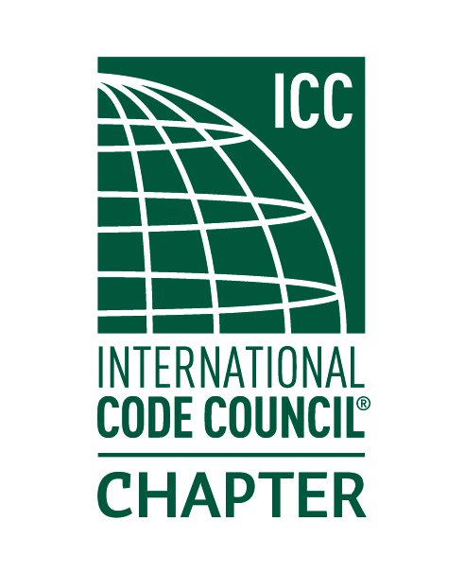

NAPA SOLANO ICC CHAPTER MEETING-Minutes

- CALL TO ORDER: Meeting called to order by Rick I at 5:34pm

- SELF INTRODUCTIONS: 18 people in attendance

- PLEDGE OF ALLEGIANCE: Rick lead the group in the pledge of allegiance.

- APPROVAL OF APRIL MINUTES: Darrell C motioned to approved the April minutes, Greg S provided a second.

- TREASURER REPORT: Erik Hagström- please see the attached treasurer report.

- DINNER: Provided by Kinders BBQ…excellent dinner!

- CODE QUIZ: Provided by: BPR Consulting. Thank you, Ron Beehler, please see the attached code quiz.

- SPEAKER: Josh Pino- Quality Control Manager with Kustom Disaster Recovery. The following topics will be discussed.
Josh presented on emergency services provided by Kustom Disaster Recovery Group related to board up and shoring buildings that have been damaged in a fire.
- Insurance claim process
- Site mitigation- reviewed equipment/ humidifier/ containment and water extraction
- Reconstruction of damaged properties; estimating and adjusters provide a review then a contract is set up with restoration company. A permit is secured then construction of the re-build. Insurance companies need corrections to assist with the rebuild. 9-month displacement coverage for loss of structure.
- Interaction with local building & fire departments- length of permitting process, electronic intake process. Josh discussed they are at the beginning stages of pursuing legislation to assist with expedited permitting for minor permitting for structural repairs.
- Current jurisdictional permitting
- Thanks Josh!

- AGENCIES REPORT
- CALBO-California Building Officials- CALBO Update provided,
- ICC Region 1-None
- California Energy Commission- Efficiency division update provided and attached.
- CBOAC- County Building Officials of California-None
- NEW BUSINESS
- Nandi-ICC Chapter Leadership Academy Orlando Florida April 5th-7th – Nandi was not able to attend the meeting for an update.
- Reminder: Chapter Lunch meeting July 11:00-1:00 Fairfield Cordelia Library.
- May-Building Safety Month Proclamation- Brian F read the chapter proclamation and provided the proclamation to Rick I.

- OLD BUSINESS
- Website update- The website is complete, please check it out! https://napasolanoicc.org/
- Solar App Training April 17th -Special thanks to Mike Schiele City of
Benicia!
- Education Committee Volunteers still needed!

Greg S is looking into an 11A/B class provided by John Caprarelli for the chapter. $160 per attendee with the manual. Greg will report back to the chapter on providing a CASp class with costs and a potential date for the training. Thanks Greg!

- INSPECTOR TIME: Please bring your code items for discussion!

- ADJOURNMENT

