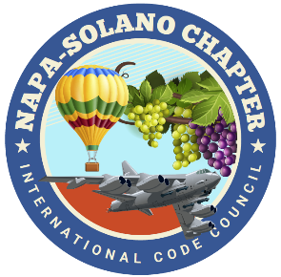

2024
BOARD OF DIRECTORS:

PRESIDENT
Rick Ishibashi
Solano County
Building Inspector

Vice-President
Nandi Cola-Loggins
Solano Economic/Bayren

SECRETARY
Brian Frenger
CBO City of Elk Grove
CSG Consultants

TREASURER
Erik Hagström
County of Solano
Planning - Civic Spark Fellow

PAST PRESIDENT
Bill Collins
County of Lake
Building Official

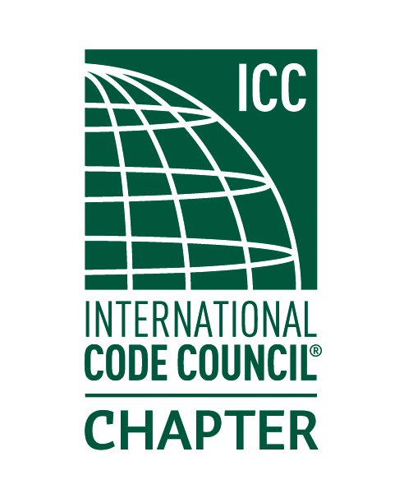

NAPA SOLANO ICC CHAPTER MEETING-July 10th 11am-1pm
Fairfield Cordelia Library suite 200

- CALL TO ORDER:

- SELF INTRODUCTIONS:

- PLEDGE OF ALLEGIANCE:

- APPROVAL OF JUNE MINUTES:

- TREASURER REPORT: Erik Hagström

- LUNCH: Provided by: Local Pizza

- CODE QUIZ: Monthly code quiz provided by BPR Consulting

- SPEAKER: California Energy Commission- Chris Olvera discussion topics will include ADU’s and decarbonization.

- AGENCIES REPORT
- CALBO-California Building Officials
- ICC Region 1
- California Energy Commission
- CBOAC- County Building Officials of California
- California Energy Commission
- NEW BUSINESS
- Napa Solano Training: NFPA 855 2023 edition on Energy Storage Systems- Friday July 26th 8-5 this class is offered in an in-person or virtual presentation. Sign up today!
- Volunteers needed for the Napa Solano Annual BBQ- Friday August 23rd Pena Adobe Pavilion- Fairfield

- OLD BUSINESS
- Greg Shriver 11A/11B class provided by John Caprarelli update.

- INSPECTOR TIME: Please bring your code items for discussion!

- ADJOURNMENT

