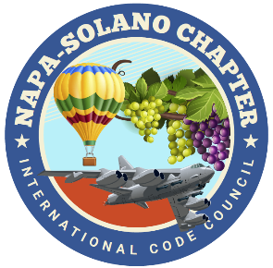

2024
BOARD OF DIRECTORS:

PRESIDENT
Rick Ishibashi
Solano County
Building Inspector

Vice-President
Nandi Cola-Loggins
Solano Economic/Bayren

SECRETARY
Brian Frenger
CBO City of Elk Grove
CSG Consultants

TREASURER
Erik Hagström
County of Solano
Planning - Civic Spark Fellow

PAST PRESIDENT
Bill Collins
County of Lake
Building Official

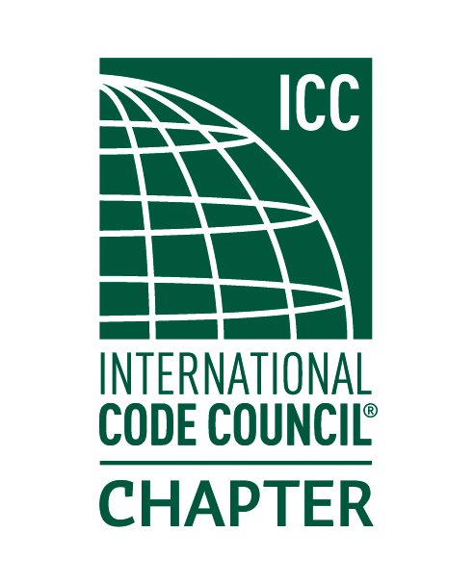

NAPA SOLANO ICC CHAPTER MEETING-June 5th

- CALL TO ORDER:

- SELF INTRODUCTIONS:

- PLEDGE OF ALLEGIANCE:

- APPROVAL OF APRIL MINUTES:

- TREASURER REPORT: Erik Hagström

- DINNER: Provided by: La Cabana Mexican Food

- CODE QUIZ: Provided by: BPR Consulting

- SPEAKER: Solano County Environmental Health: Lead hazards and unpermitted food establishments

- AGENCIES REPORT
- CALBO-California Building Officials
- ICC Region 1
- California Energy Commission
- CBOAC- County Building Officials of California
- California Energy Commission
- NEW BUSINESS
- Nandi-ICC Chapter Leadership Academy Orlando Florida April 5th-7th
- Reminder: Chapter Lunch meeting July 11:00-1:00 Fairfield Cordelia Library.
- Napa Solano Training: Installation of Energy Storage Systems NFPA 855. Training is hybrid on July 26th 8am-5pm, please see the flier and support the chapter!
- Volunteers needed for the Napa Solano Annual BBQ

- OLD BUSINESS
- Greg Shriver 11A/11B class provided by John Caprarelli update.

- INSPECTOR TIME: Please bring your code items for discussion!

- ADJOURNMENT

