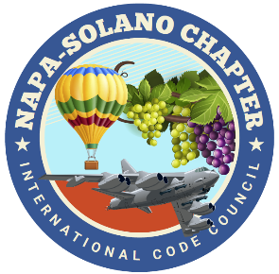

2024
BOARD OF DIRECTORS:

PRESIDENT
Rick Ishibashi
Solano County
Building Inspector

Vice-President
Nandi Cola-Loggins
Solano Economic/Bayren

SECRETARY
Brian Frenger
CBO City of Elk Grove
CSG Consultants

TREASURER
Erik Hagström
County of Solano
Planning - Civic Spark Fellow

PAST PRESIDENT
Bill Collins
County of Lake
Building Official

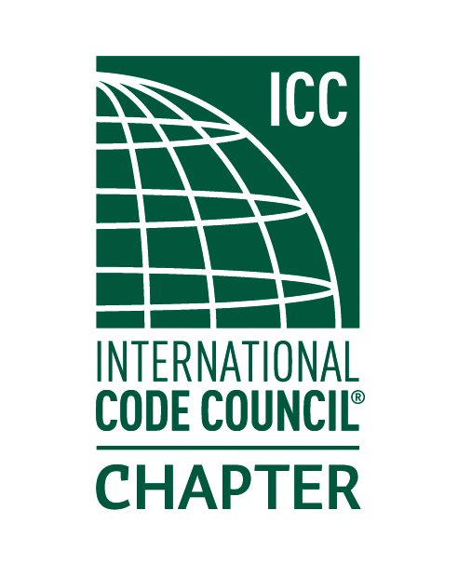

NAPA SOLANO ICC CHAPTER MEETING-June 5, 2024 Minutes

- CALL TO ORDER: Meeting called to order by Rick I at 5:34pm

- SELF INTRODUCTIONS: 17 people in attendance

- PLEDGE OF ALLEGIANCE: John Bento lead the group in the pledge of allegiance.

- APPROVAL OF APRIL MINUTES: Darrell Chappell motioned to approved the May minutes, Bill Rodgers provided a second.

- TREASURER REPORT: Erik Hagström reported - posted to website.

- DINNER: Provided by La Cabana De Suisun – So good.

- CODE QUIZ: Provided by: BPR Consulting. Thank you, Bill Rodgers.

- SPEAKER: Connie Howard and Jahniah McGill of Solano County Environmental health presenting on Lead hazards and unpermitted food vendors.
  - Targeting pre 1978 housing.
  - Seeking to team with Building Depts if stop work orders are necessary. EH does not have authority to issue a stop work. Not under Code Enforcement. AHJ’s are invited to ask for a local presentation.
  - Unpermitted food vendors are becoming a major problem. Folks just setting up shop without proper vetting. Unknown food sources and lack of sanitary facilities. EH has authority to impound equipment if necessary. Many complaints. Govt folks should not be seen supporting these vendors.

- AGENCIES REPORT
- CALBO-California Building Officials- Doug Hughes reporting
  - Supports AB2114 Opposes AB2433
  - Looking forward to CALBO education weeks in fall.
- SVABO – Bill Rodgers summarized recent Education Institute as successful.
- ICC Region 1- Tried posting June Govt Relations bulletin but file is too big for our host to accept. Looking into this.
- California Energy Commission- Efficiency update posted to website
- CBOAC- County Building Officials of California – ABM scheduled for Nov3-7, 2024

- NEW BUSINESS
- Nandi-ICC Chapter Leadership Academy Orlando Florida April 5th-7th – Nandi provided update on trip. Impressed with folks she met and mentioned other chapters across the country are looking for trainings such as we provide. She is looking into forming a Women in Codes chapter.
- Reminder: Chapter Lunch meeting July 10, 2024 11:00-1:00 Fairfield Cordelia Library.
- Napa Solano training. NFPA 855 slated for July 26 all day will be a hybrid course. Will be sending out reminders. Have a few signups so far. Projecting most will be virtual.
- Working on adjusting our payment option on the website to allow credit card payments through Paypal for our trainings.
- Volunteers needed for our annual picnic on Friday August 23 at Pena Adobe park. Pavilion is reserved. TRB will be our chef. Thank you. Need a head count and earlier access than last year to start cooking. Will start working on flyer and asking for volunteers.
- Nandi to work on the air conditioning issue for the room. Suspect it times out after 6p.

- OLD BUSINESS
- Greg Shriver 11A/11B class provided by John Caprarelli. Will email summary to board with costs and logistics. CASP test in October. Suggested we get AHJ’s to use their Accessibility funding to sponsor the course as in pay for John ($3500) then we get the sign up fees.

- INSPECTOR TIME
  - Rachel O’shea brought up a DSA bulletin for special inspections on shotcrete. It was determined the bulletin only applies to pools under DSA jurisdiction and does not apply to AHJ’s.

- ADJOURNMENT

