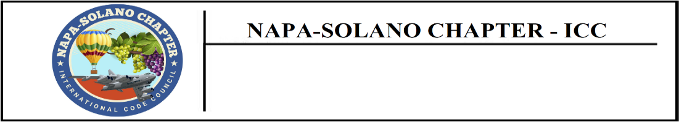

TREASURER’S REPORT – June 5th, 2024
Erik Hagstrom, Treasurer

Bank Balance as 4/3/2024 $25,127.32

Expenditures Bank Cleared

Check Date | Check # | Paid To | Reason | Clear | Amount
5/2/2024 | Zelle | Rick Ishibashi | Costco Reimbursement |  | $30.68
5/3/2024 | Debit | Kinder’s Fairfield | Chapter Meeting Dinner |  | $575.06
Total Cleared Expenditures $ 605.74

Credits/Deposits

Date | Method | Reason | Amount
5/1/24 Check Membership Dues $750.00
5/1/24 Check Membership Dues $250.00
5/1/24 Check Membership Dues $250.00
5/1/24 Check Membership Dues $250.00
5/1/24 Check Solar App Training $250.00
5/1/24 Check Solar App Training $100.00

Total Credits/Deposits $ 1,590.00

Ending Bank Balance as of 5/31/2024 $26,111.58

Checks Made, Not Cleared

Check Date | Check # | Paid To | Reason | Clear | Amount

Total Outstanding Expenditures $0.00

Debt Obligations, Not Cleared

Total Debt Obligation $0.00

Total Chapter Unencumbered Net Worth as of 5/31/2024 $26,111.58

